FINALTERM EXAMINATION
MTH301- Calculus II

Question No: 1 ( Marks: 1 ) - Please choose one

is an example of -----------

► Irrational numbers

► Rational numbers

► Integers

► Natural numbers

Question No: 2 ( Marks: 1 ) - Please choose one

Straight line is a special kind of ----------------

► Surface

► Curve

► Plane

► Parabola

Question No: 3 ( Marks: 1 ) - Please choose one

An ordered triple corresponds to ----------- in three dimensional space.

► A unique point

► A point in each octant

► Three points

► Infinite number of points

Question No: 4 ( Marks: 1 ) - Please choose one

The angles which a line makes with positive x ,y and z-axis are known as ------------

► Direction cosines

► Direction ratios

► Direction angles

Question No: 5 ( Marks: 1 ) - Please choose one

Is the function 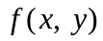 continuous at origin? If not, why?
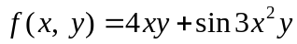

► is continuous at origin

► 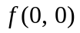 is not defined

► is defined but 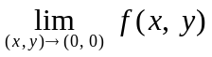 does not exist

► is defined and exists but these two numbers are not equal.

Question No: 6 ( Marks: 1 ) - Please choose one

Match the following vector-valued function with its graph.
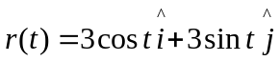 and 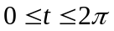

► 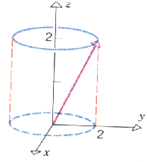

► 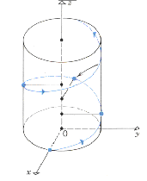

► 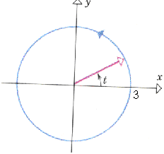

► 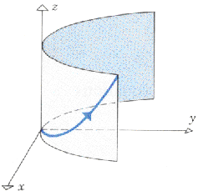

Question No: 7 ( Marks: 1 ) - Please choose one

Match the following vector-valued function with its graph.
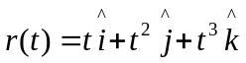 and 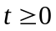

►

►

►

► 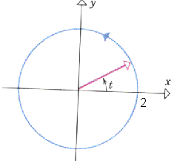

Question No: 8 ( Marks: 1 ) - Please choose one

What are the parametric equations that correspond to the following vector equation?
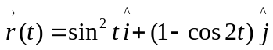

► 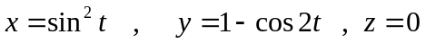

► 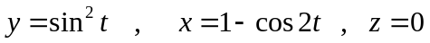

► 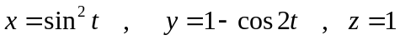

► 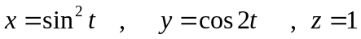

Question No: 9 ( Marks: 1 ) - Please choose one

Is the following vector-valued function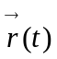 continuous at 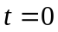? If not, why?
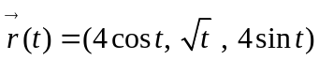

► 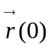is not defined

► is defined but 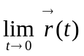 does not exist

► is defined and exists but these two numbers are not equal.

► 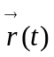is continuous at

Question No: 10 ( Marks: 1 ) - Please choose one

What is the derivative of following vector-valued function?
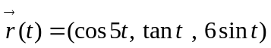

► 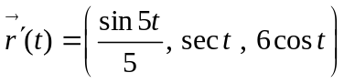

► 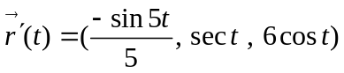

► 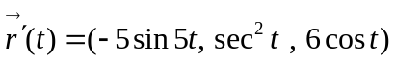

► 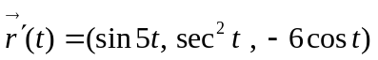

Question No: 11 ( Marks: 1 ) - Please choose one

The following differential is exact
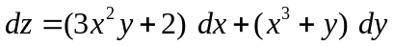

► True

► False

Question No: 12 ( Marks: 1 ) - Please choose one

The following differential is exact
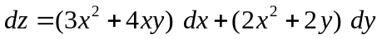

► True

► False

Question No: 13 ( Marks: 1 ) - Please choose one

Which one of the following is correct Wallis Sine formula when is odd and 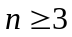?

► 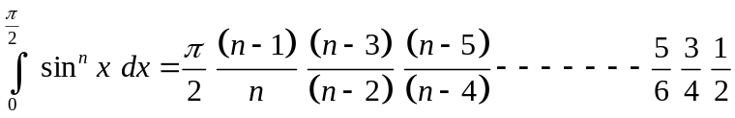

► 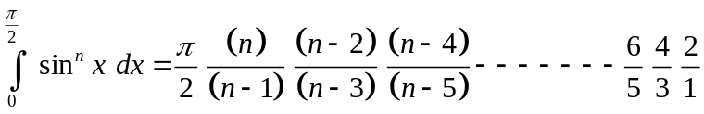

► 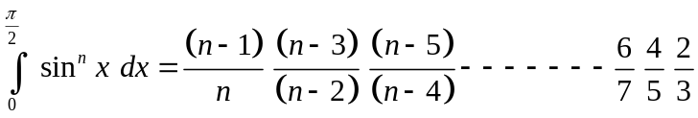

► 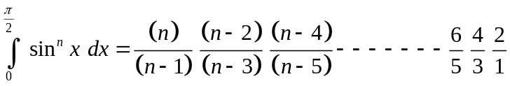

Question No: 14 ( Marks: 1 ) - Please choose one

Which of the following is correct?

► 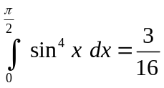

► 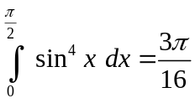

► 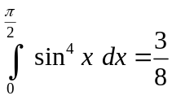

► 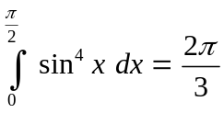

Question No: 15 ( Marks: 1 ) - Please choose one

Match the following equation in polar co-ordinates with its graph.
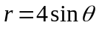

► 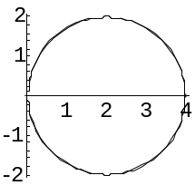

► 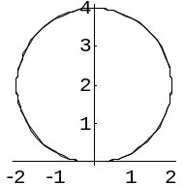

► 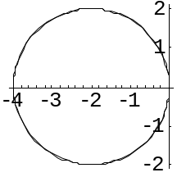

► 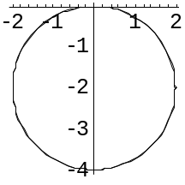

Question No: 16 ( Marks: 1 ) - Please choose one

If the equation of a curve, in polar co-ordinates, remains unchanged after replacing 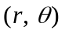by 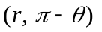then the curve is said to be symmetric about which of the following?

► Initial line

► y-axis

► Pole

Question No: 17 ( Marks: 1 ) - Please choose one

What is the period of a periodic function defined by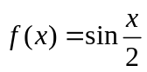?

► 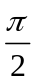

►

► 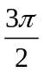

► 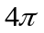

Question No: 18 ( Marks: 1 ) - Please choose one

Match the following periodic function with its graph.
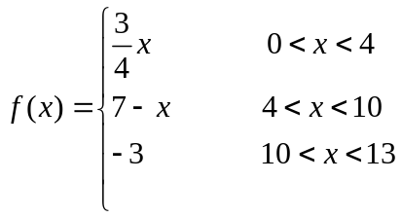

► 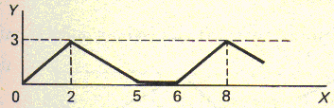

► 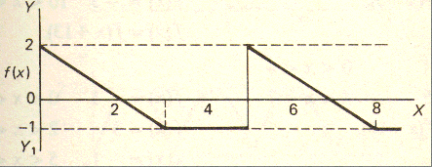

► 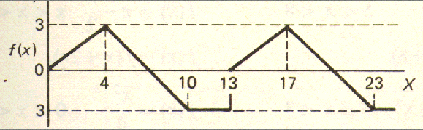

► 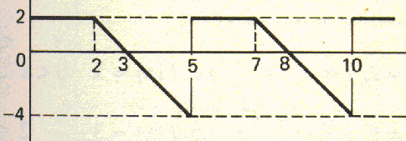

Question No: 19 ( Marks: 1 ) - Please choose one

What is the period of periodic function whose graph is as below?

► 2

► 3

► 4

► 5

Question No: 20 ( Marks: 1 ) - Please choose one

What is the period of periodic function whose graph is as below?
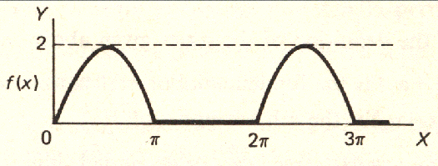

► 0

► 2

►

► 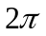

Question No: 21 ( Marks: 1 ) - Please choose one

Polar co-ordinates of a point are 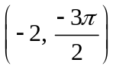. Which of the following is another possible polar co-ordinates representation of this point?

► 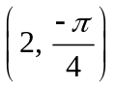

► 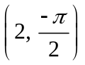

► 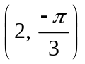

► 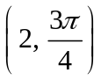

Question No: 22 ( Marks: 1 ) - Please choose one

The function 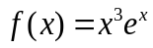 is -------------

► Even function

► Odd function

► Neither even nor odd

Question No: 23 ( Marks: 1 ) - Please choose one

The graph of an even function is symmetrical about ---------------

► x-axis

► y-axis

► origin

Question No: 24 ( Marks: 1 ) - Please choose one

At which point the vertex of parabola, represented by the equation 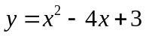, occurs?

► 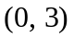

► 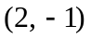

► 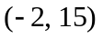

► 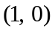

Question No: 25 ( Marks: 1 ) - Please choose one

The equation 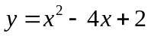 represents a parabola. Find a point at which the vertex of given parabola occurs?

► 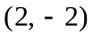

► 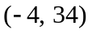

► 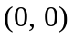

► 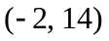

Question No: 26 ( Marks: 1 ) - Please choose one

Is the function continuous at origin? If not, why?
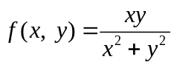

► is continuous at origin

► does not exist

► is defined and exists but these two numbers are not equal.

Question No: 27 ( Marks: 1 ) - Please choose one

Sign of line integral is reversed when -----------

► path of integration is divided into parts.

► path of integration is parallel to y-axis.

► direction of path of integration is reversed.

► path of integration is parallel to x-axis.

Question No: 28 ( Marks: 1 ) - Please choose one

What is Laplace transform of a function F(t)?

(s is a constant)

► 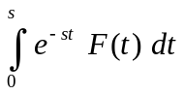

► 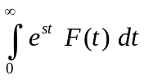

► 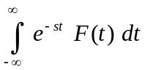

► 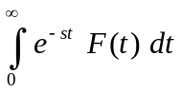

Question No: 29 ( Marks: 1 ) - Please choose one

What is the value of 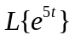if denotes laplace transform?

► 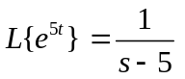

► 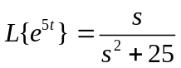

► 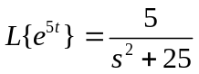

► 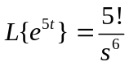

Question No: 30 ( Marks: 1 ) - Please choose one

What is the Laplace Inverse Transform of 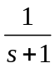

► 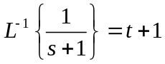

► 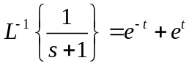

► 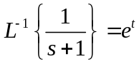

► 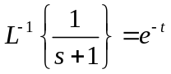

Question No: 31 ( Marks: 1 ) - Please choose one

What is Laplace Inverse Transform of 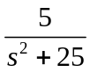

► 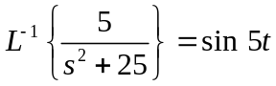

► 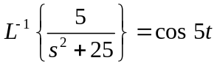

► 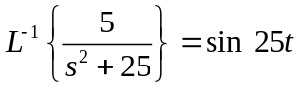

► 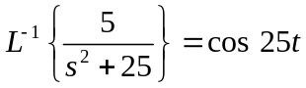

Question No: 32 ( Marks: 1 ) - Please choose one

What is 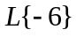if denotes Laplace Transform?

► 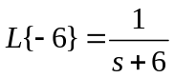

► 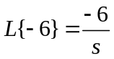

► 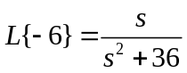

► 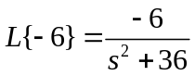

Question No: 33 ( Marks: 1 ) - Please choose one

Evaluate the line integral 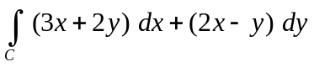 where C is the line segment from (0, 0) to (2, 0).

► 6

► -6

► 0

► Do not exist

Question No: 34 ( Marks: 1 ) - Please choose one

Evaluate the line integral 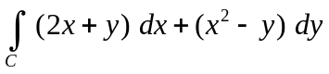 where C is the line segment from (0, 0) to (0, 2).

► -4

► -2

► 0

► 2

Question No: 35 ( Marks: 1 ) - Please choose one

Plane is an example of ---------------------

► Curve

► Surface

► Sphere

► Cone

Question No: 36 ( Marks: 1 ) - Please choose one

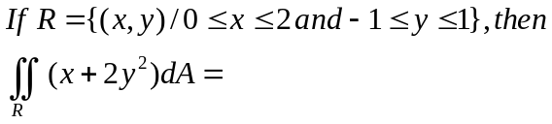

► 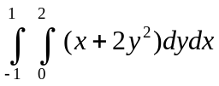

► 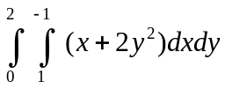

► 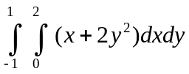

► 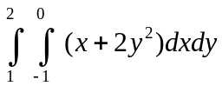

Question No: 37 ( Marks: 1 ) - Please choose one

To evaluate the line integral, the integrand is expressed in terms of x, y, z with

► 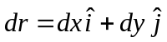

► 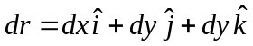

► 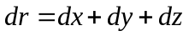

► 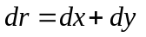

Question No: 38 ( Marks: 1 ) - Please choose one

Match the following equation in polar co-ordinates with its graph.
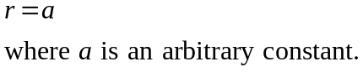

► 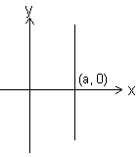

► 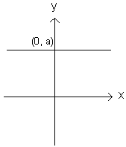

► 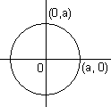

► 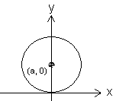

Question No: 39 ( Marks: 1 ) - Please choose one

Which of the following is true for a periodic function whose graph is as below?
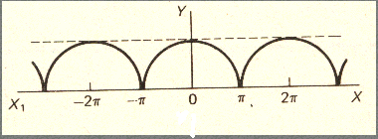

► Even function

► Odd function

► Neither even nor odd function

Question No: 40 ( Marks: 1 ) - Please choose one

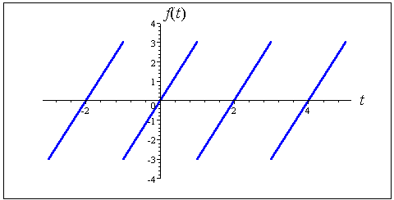

The graph of “saw tooth wave” given above is --------------

► An odd function

► An even function

► Neither even nor odd

Question No: 41 ( Marks: 2 )

Equation of a curve in polar co-ordinates is 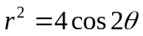
Discuss the symmetry of graph of this curve about y-axis.

Question No: 42 ( Marks: 2 )

Determine whether the following differential is exact or not.
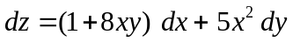

Question No: 43 ( Marks: 2 )

Prove whether the following function is even, odd or neither.
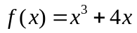

Question No: 44 ( Marks: 3 )

Find 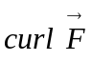, if 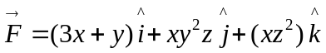

Question No: 45 ( Marks: 3 )

Determine the fourier co-efficient 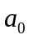 of the following function.
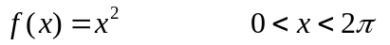

Question No: 46 ( Marks: 3 )

Find all possible polar co-ordinates representations of the point P whose rectangular co-ordinates are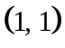.

Question No: 47 ( Marks: 5 )

Using definite integral, find area of the region that is enclosed between the curves 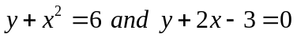
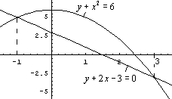

Question No: 48 ( Marks: 5 )

Evaluate the following double integral
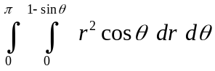

Question No: 49 ( Marks: 5 )

Determine the fourier co-efficient 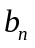of the following function.

Question No: 50 ( Marks: 10 )

Let is the surface bounded by the planes,,,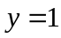,  and . If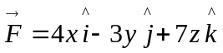, use Divergence Theorem to find 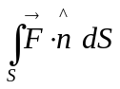 where denote the unit outer normal to S.

